# [**‘Law & Order: Organized Crime’: Camilla Belle And Gus Halper Board Season 3**](https://deadline.com/2022/08/law-order-organized-crime-camilla-belle-gus-halper-season-3-1235091326/)

[‘Law and Order:Organized Crime’: Camilla Belle e Gus Halper aceitos na temporada 3](https://deadline.com/2022/08/law-order-organized-crime-camilla-belle-gus-halper-season-3-1235091326/)

By [Rosy Cordero](https://deadline.com/author/rosy-cordero/)

## [**Rosy Cordero**](https://deadline.com/author/rosy-cordero/)

*Senior TV Reporter*

[@SocialRosy](https://twitter.com/SocialRosy)

August 12, 2022 3:00pm

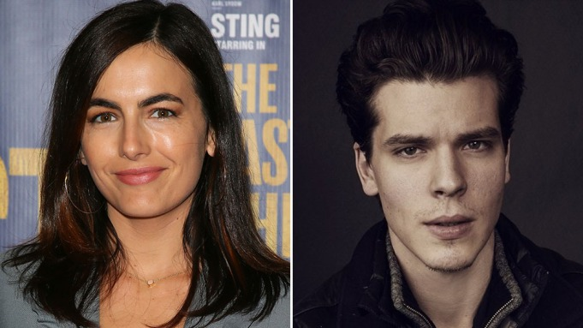

Getty, Courtesy

**EXCLUSIVE:** [Camilla Belle](https://deadline.com/tag/camilla-belle/) (*Carter*, *The Ballad of Jack and Rose*) and [Gus Halper](https://deadline.com/tag/gus-halper/) (*Fear the Walking Dead*, *Love Life*) have joined the cast of [NBC](https://deadline.com/tag/nbc/)’s *Law & Order: Organized Crim*e for its upcoming third season. Belle and Halper will portray New York City power couple Pearl Serrano and Teddy Silas, respectively.

**EXCLUSIVO**: [Camilla Belle](https://deadline.com/tag/camilla-belle/) (*Carter*, *The Ballad of Jack and Rose*) e Gus Halper (*Fear the Walking Dead*, *Love Life*) juntaram ao elenco de *Law & Order: Organized Crim*e da [NBC](https://deadline.com/tag/nbc/) para sua próxima terceira temporada. Belle e Halper retratarão o casal poderoso de New York City Pearl Serrano e Teddy Sillas, respectivamente.

The series follows *Law & Order: SVU* character Elliot Stabler (Christopher Meloni), a veteran detective who returns to the New York Police Department as part of the Organized Crime Task Force following his wife’s murder.

A série segue o personagem *Law & Order: SVU* Elliot Stabler (Christopher Meloni), um detetive veterano que retornou para o Departamento de Polícia de New York como parte da Força Tarefa do Crime Organizado seguindo o assassinato de sua esposa.

[Deadline recently confirmed](https://deadline.com/2022/07/law-and-order-organized-crime-rick-gonzalez-brent-antonello-season-3-cast-1235081473/) the addition of Rick Gonzalez and Brent Antonello, who will join Stabler as part of the task force. Danielle Moné Truitt and Ainsley Seiger also star.

[Deadline recentemente confirmou](https://deadline.com/2022/07/law-and-order-organized-crime-rick-gonzalez-brent-antonello-season-3-cast-1235081473/) a adição de Rick Gonzalez e Brent Antonello, qu irão juntar Stabler como parte da força tarefa. Danielle Moné Truitt e Ainsley Seiger também estrelam.

The series is produced by Universal Television, a division of Universal Studio Group and Wolf Entertainment. Executive producers include Dick Wolf, Bryan Goluboff, Barry O’Brien, John Polson, Paul Cabbad, Arthur W. Forney, Meloni and Peter Jankowski.

A série é produzida pela Universal Television, a divisão da Universal Studio Group e Wolf Entertainment. Produtores Executvos incluem Dick Wolf, Bryan Goluboff, Barry O’Brien, John Polson, Paul Cabbad, Arthur W. Forney, Meloni e Peter Jankowski.

Belle most recently co-starred in the Korean action film *Carter* for Netflix and the Tubi feature *10 Truths About Love.* Other films on her résumé include *The Ballad of Jack and Rose*, starring Daniel Day-Lewis; *The Chumscrubber*, with Ralph Fiennes and Allison Janney; *The Quiet*, with Eddie Falco; and *When a Stranger Calls*.

Belle mais recentemente co-estrelou no filme de ação Korean *Carter* para Netflix e o recurso Tubi *10 Truths About Love.* Outros filmes em seu currículo incluem *The Ballad of Jack and Rose*, estrelando Daniel Day-Lewis; *The Chumscrubber*, com Ralph Fiennes e Allison Jenney; *The Quiet*, com Eddie Falco; e *When a Stranger Calls*.

She is repped by Silver Lining Entertainment and Jackoway Austen Tyerman.

Ela é representada por Silver Linning Entertainment e Jackoway Austen Tyerman.

Halper recently wrapped on the upcoming biopic *Rustin*, directed by George C. Wolfe for Netflix. He can also be seen in AMC’s *Fear the Walking Dead* and HBO’s *Love Life.*

Halper recentemente se envolveu no próximo cinebiografia *Rustin*,dirigido por George C Wolfe pela Netflix. Ele também pode ser visto em *Fear the Walking Dead* da AMC e *Love Life* da HBO.

Halper returns to NBC and the *Law & Order* franchise following a successful run on *Law & Order: True Crime—The Menendez Brothers* in the role of Erik Menendez. Other film credits include *Goat*, *Holler* and *Cold Pursuit*.

Halper retorna para NBC e a franquia *Law & Order* seguindo uma corrida bem-sucedida *Law & Order: True Crime—The Menendez Brothers* no personagem de Erik Menendez. Outros créditos de filme incluem *Goat*, *Holler* e *Cold Pursuit*.

He is repped by Gersh, and Authentic Talent and Literary Management.

Ele é representado por Gersh, e Authentic Talent and Literary Management.